

Take Flight Activity

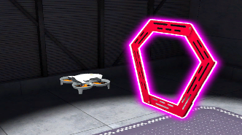 | Fly a virtual VEX AIR Drone to complete missions and earn badges!

Step-By-Step:
- Open VEXcode AIR by navigating to codeair.vex.com.

  - Connect the controller by selecting the Controller icon and following the prompts.
  - Select the Simulator tab to open the VEX AIR Flight Simulator.
- Select the Flight School button in the lower left corner to open the Flight School Missions menu.
- You will complete the Throttle Mission together as a whole group.
  - Press the Power button on the virtual drone in the center of the screen to disengage the Propeller Lock.
  - Takeoff and fly up through the white rings and land on the platform to earn a badge.
  - Select Retry Mission so your partner can fly the same mission.
- Next, complete the Pitch Flight, Yaw Flight, and Roll Flight Missions in your group.

VEX AIR Reminders
- To Takeoff: Press the Takeoff & Land button to open the project menu. Then hold the button until the drone takes off from the platform.
- To Land: Press the Takeoff & Land button to open the land menu. Then press the Land button on the controller screen to land.

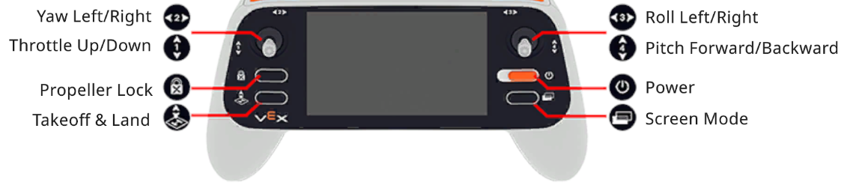

Take Flight Girl Powered Mission Log

Mission: Throttle Flight
Location: Ring Layout | Module: Magnet
Mission Objectives:
- Throttle up through both white rings above the platform
- Practice adjusting the maximum Z Height
- Practice changing camera views
- Throttle down through both white rings and land on the platform
Mission Prep:
Note which features of the VEX AIR Drone Controller are used to do each of the following:
Take off
Change the camera view
Throttle up or down

Log your practice flights. Note things like which camera view you preferred for this task and why.
Flight # | Duration (min/sec) | Mission Complete? | Collision Count | Reflection

Take Flight Girl Powered Mission Log

Mission: Pitch Flight
Location: Ring Layout | Module: Magnet
Mission Objectives:
- Pitch forward through the first red ring
- Pitch backward through the ring
- Land on the platform
Mission Prep:
Note which features of the controller are used to pitch forward, pitch backward, take off, and land:
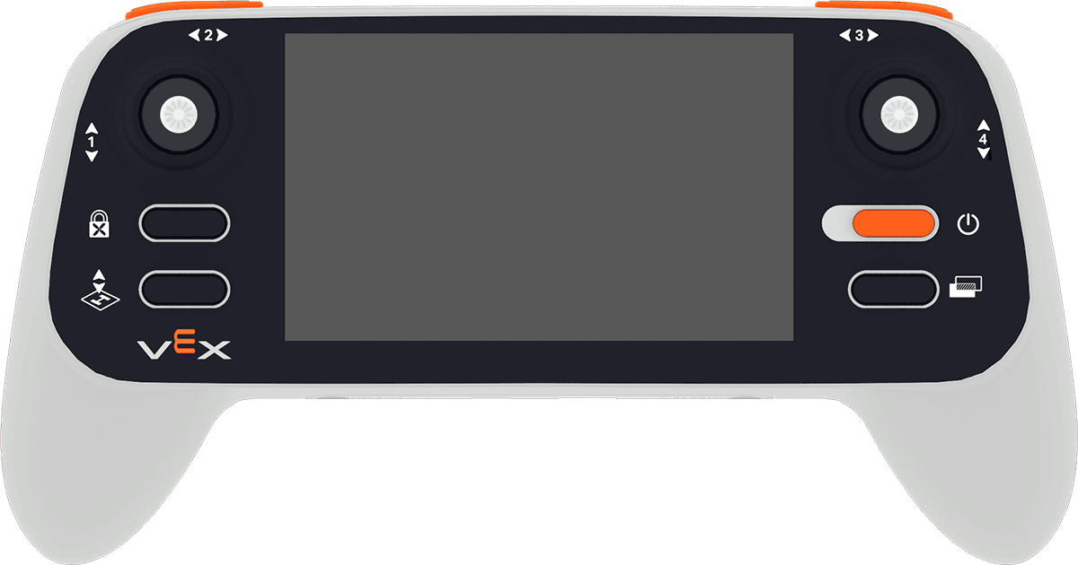

Log your practice flights. Note things like how you moved the joystick for precise movements.
Flight # | Duration (min/sec) | Mission Complete? | Collision Count | Reflection

Take Flight Girl Powered Mission Log

Mission: Yaw Flight
Location: Ring Layout | Module: Magnet
Mission Objectives:
- Yaw (turn) left to face the first yellow ring
- Fly through the first yellow ring and back to the takeoff location
- Yaw (turn) right to face the second yellow ring
- Fly through the second yellow ring and back to land on the platform
Mission Prep:
Note which features of the controller are used to turn left, turn right, pitch forward, pitch backward, and change the camera views:
Log your practice flights. Note things like which camera view you preferred for this task and why.
Flight # | Duration (min/sec) | Mission Complete? | Collision Count | Reflection

Take Flight Girl Powered Mission Log

Mission: Roll Flight
Location: Ring Layout | Module: Magnet
Mission Objectives:
- Roll left through the first blue ring
- Roll right through the second blue ring
- Land on the platform
Mission Prep:
Note which features of the controller are used to roll left, roll right, take off, and land:

Log your practice flights. Note things like how you moved the joystick for precise movements.
Flight # | Duration (min/sec) | Mission Complete? | Collision Count | Reflection

Take Flight

Activity Notes

Hands-on time for this activity is approximately 30-45 minutes.

Facilitating the Activity

- Introduce the activity. Share the context here to help students connect what they will do with the virtual drone to real-world applications.
 | Before drone pilots fly in real environments, they often practice in simulators. A simulator gives pilots a safe place to learn the controls, make mistakes, and build the accuracy they need before flying in more complex situations.  Drones are used for all kinds of real-world jobs, from filming events and inspecting buildings to surveying land, monitoring crops, and supporting emergency response. In each of those situations, pilots need to control the drone carefully, adjust their movements, and stay aware of what is around them.  Today, you’ll use the VEX AIR Flight Simulator to practice those same kinds of skills. As you complete each mission, pay attention to how the drone responds, how small movements affect your flight, and how your control improves with practice.
- Complete the first mission together. Walk students through the steps to connect to the simulator, open Flight School, and complete the Throttle Mission together as a guided demonstration.
  - Select the Throttle Mission from the Flight School Missions menu.
  - Takeoff, fly through both white rings, then land on the platform.
    - Press the Power button on the virtual drone in the center of the screen to disengage the Propeller Lock.
    - After the first student flies, have them select Retry Mission so the other partner can fly the same mission.
  - Make sure students know how to fill in their flight data in the Mission Log.
    - Flight statistics can be found in the badge.
    - Have students fill in their reflections while their partner flies.
  - Encourage students to practice each mission multiple times, so they can improve their piloting skills.
- Direct students to complete the Pitch Flight, Yaw Flight, and Roll Flight Missions independently.
  - Move around the room and talk with students, asking questions like:
    - What felt harder than expected while flying?
    - How are you remembering which joystick controls what drone movement?
    - Which mission is your favorite so far? Why?
  - Both students should try each mission multiple times, so they gain practice with the controls.
  - Remind students to log their flights in their Mission Logs, and talk with their partners about their flights.

Extending the Activity

- Complete more missions in Flight School! Have students choose additional Flight School Missions to complete and try out more complex maneuvering. Use the following suggestions to help them get started:
  - Bowtie Pattern - will combine the Yaw and Roll Flights into one unique flight path.
  - Tunnel Flight - this is a challenging combination of pitch and throttle controls.
  - Ring Flight Challenge - challenge students to see how many rings they can fly through on the full field.

- Explore moving objects with modules. Have students try a mission on the Competition Layout to experiment with using modules on the virtual drone.
  - Try the Single Cargo Pickup Mission to explore how to use the Magnet Module to pick up and drop cargo during flight. Check out this lesson from the VEX AIR Virtual Flight Course to learn more about using the Magnet Module.
  - Try the Orbit Ball Drop Mission to explore how to use the Motorized Hook Module to pick up and deliver an orbit ball. Check out this lesson from the VEX AIR Virtual Flight Course to learn more about using the Motorized Hook Module.

